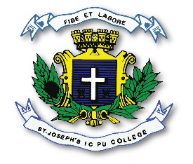
ST. JOSEPH’S INDIAN COMPOSITE PU COLLEGE
#23, Vittal Mallya Road, Bangalore – 560001.

SUBJECT: BIOLOGY (36)
I PUC
PORTIONS FOR I TEST – 2023-24

Chapters - Unit I

1. The Living World.
2. Biological Classification.
3. Plant Kingdom.
4. Animal Kingdom.
5. Morphology of Flowering plants. (up to Leaf 5.33)

